**MIS - UNIT 4**

# DEVELOPMENT OF MIS

**Development of Long Rate Plans of the MIS**

 Any kind of business activity calls for long range plans for success, the same being true for MIS. The plan for development and its implementation is a basic necessity for MIS. In MIS the information is recognized as a major resource like capital, time and capacity. And if this resource is to be managed well, it calls upon the management to plan for it and control it for the appropriate use in the organization. Most of the organizations do not recognize `Information' as a resource. They have looked at information as one of the many necessities for conducting the business activity. Hence, due regard is often not given for its planned development and use. Many organizations have spent financial resources on computers purely to expedite the activity of data collection and processing.

 Many organizations have purchased computers for data processing and for meeting the statutory requirements of filing the returns and reports to the Government. Computers are used mainly for computing and accounting the business transactions and have not been considered as a tool for information processing.

 The organizations have invested in computers and expanded its use by adding more or bigger computers to take care of the numerous transactions in the business. In this approach the information processing function of the computers in the organization never got it s due regard as an important asset to the organization. In fact, this function is misinterpreted as data processing for expeditious generation of reports and returns, and not as information processing for management action and decisions.

 However, the scheme has been changing since late eighties when the computers became more versatile, in the function of Storage, Communication, Intelligence and Language. The computer technology is so advanced that the barriers of storage, distance, understanding of language and speed are broken.

 With the advancement of computer technology, it is now possible to recognize information as valuable resources like money and capacity.

 In short, we need a Management Information System flexible enough to deal with the changing information needs of the organization. It should be conceived as an open system continuously interacting with the business environment with a built-in mechanism to provide the desired information as per the new requirements of the management. The designing of such as open system is a complex task. It can be achieved only if the MIS is planned, keeping in view, the plan of the business management of the organization.

 The plan of MIS is concurrent to the business plan of the organization. The information needs for the implementation of the business plan should find place in the MIS. To ensure such an alignment possibility, it is necessary that the business plan – strategic or otherwise, states the information needs. The information needs are the traced to the source data and the systems in the organization which generate such a data. The plan of development of the MIS is linked with the steps of the implementation in a business development plan. The system of information generation is so planned that strategic information is provided for the strategic planning, control information is provided for a short term planning and execution.

## Contents of the MIS Plan

 A long range MIS plan provides direction for the development of the systems, and provides a basis for achieving the specific targets or tasks against a time frame. The plan would have the following contents which will be dealt by the designer under a support from the top management.

[**Different Approaches to Development of MIS**](http://ecomputernotes.com/mis/system-development-approaches/what-are-different-approaches-to-development-of-mis)

There are two basic approaches for development of MIS :

a) **System development life cycle** : In order to develop a system successfully, it is managed by breaking the total development process into smaller basic activities or phases. Any system development process, in general, is understood to have the following phases

i) Systems Planning

ii) Systems Analysis

iii) Systems Design

iv) Systems Implementation

v) Systems Operation and Support (System Maintenance)

b) **Prototyping :** Prototyping is the process of creating an incomplete model of the future full-featured system, which can be used to let the users have a first idea of the completed program or allow the clients to evaluate the program.

**Ascertaining class of information**

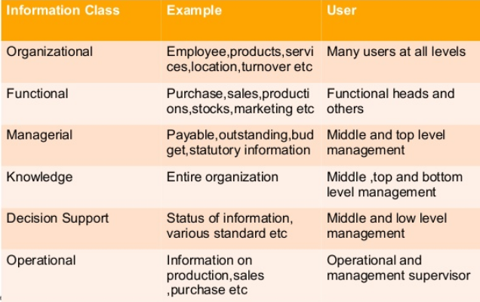

**Determining the information requirement**

* The difficulty to determine a correct and complete sets of information is on account of the factor given below:

1)The capability constraint of human being as an information processor

2)The nature and the variety of information in précised terms

3)Reluctance of decision maker to spell out the information

4)The ability of the decision makers to specify information

* There are 4 methods of determining information requirements

1)Asking or interviewing

2)Determining from existing system

3)Analyzing the critical success factors

4)Experimentation and modeling

**Development and implementation of MIS**

* The plan consists of various system and subsystems
* The choice of the subsystem depends on the its positions in the total mis plan
* The designer first develops systems independently and start integrated them with other systems
* Basically 2 approaches effected on MIS

1)Prototype approach

2)Life cycle approach

**Prototype approach**

* It is useful for complex system
* Prototyping is a process of progressively ascertaining the information needs, developing methodology, trying it out on a smaller scale with respect to the data and the complexity.
* Designers task is complex and full of difficult in this approach
* Multiple user can involve in this approach

